Chapter 1

INTRODUCTION

The Snake Game is a game developed and written in openGL programming interface.

This game is based on the concept of popular mobile game Snake. The game requires the user/player to maneuver an animated creature within a confined region. The Creature (snake) is required to catch a Food Particle which is also within that region.

The player earns 1 point for each Food Particle eaten. The snake grows longer as it eats the Food Particle.
To increase the spontaneity, the level of the game increases when the number of Food Particles eaten is multiple of five.

The snake is not allowed to cross its own path. If the snake tries to do so, the player will lose the game.

The score and level of game is displayed at the bottom-left of the screen. Once the game is over, the last game score with level reached is also displayed at bottom-left corner.

We are using openGL API’s to create a 2D game named THE SNAKE GAME.
Specifically the following features are implemented:
Snake’s body being implemented in the form of squares, each of which is aligned with the screen frame.
After every short interval, the position of snake being updated accordingly to user inputs.
Selection of random position in the screen to generate the Food Particle (food), and determining the instance when the snake eats the Food Particle. Incrementing the score and level accordingly.
At the same time determining the instance if the snake tries to cross its own path. If so, appropriate message of game over along with the last game score to be displayed on screen.
Taking user inputs at regular intervals and updating the state of game accordingly.

CHAPTER 2

OPENGL AND ITS GRAPHICS ARCHITECTURE

OpenGL (Open Graphics Library) is a standard specification defining a cross-language, cross-platform API for writing applications that produce 2D and 3D computer graphics. The interface consists of over 250 different function calls which can be used to draw complex three-dimensional scenes from simple primitives. OpenGL was developed by Silicon Graphics Inc.
In the 1980s, developing software that could function with a wide range of graphics hardware was a real challenge. Software developers wrote custom interfaces and drivers for each piece of hardware. This was expensive and resulted in much duplication of effort. By the early 1990s, Silicon Graphics (SGI) was a leader in 3D graphics for workstations. Their IRIS GL API^{[9]} was considered the state of the art and became the de facto industry standard, overshadowing the open standards-based PHIGS. This was because IRIS GL was considered easier to use, and because it supported immediate mode rendering. By contrast, PHIGS was considered difficult to use and outdated in terms of functionality.
SGI's competitors (including Sun Microsystems, Hewlett-Packard and IBM) were also able to bring to market 3D hardware, supported by extensions made to the PHIGS standard. This in turn caused SGI market share to weaken as more 3D graphics hardware suppliers entered the market. In an effort to influence the market, SGI decided to turn the IrisGL API into an open standard.
SGI considered that the IrisGL API itself wasn't suitable for opening due to licensing and patent issues. Also, the IrisGL had API functions that were not relevant to 3D graphics. For example, it included a windowing, keyboard and mouse API, in part because it was developed before the X Window System and Sun's News systems were developed.
In addition, SGI had a large number of software customers; by changing to the OpenGL API they planned to keep their customers locked onto SGI (and IBM) hardware for a few years while market support for OpenGL matured. Meanwhile, SGI would continue to try to maintain their customers tied to SGI hardware by developing the advanced and proprietary Iris Inventor and Iris Performer programming APIs.As a result, SGI released the OpenGL standard.
2.1OpenGL Architecture
OpenGL serves two main purposes:
To hide the complexities of interfacing with different 3D accelerators, by presenting the programmer with a single, uniform API.
To hide the differing capabilities of hardware platforms, by requiring that all implementations support the full OpenGL feature set (using software emulation if necessary).
OpenGL's basic operation is to accept primitives such as points, lines and polygons, and convert them into pixels. This is done by a graphics pipeline known as the OpenGL state machine. Most OpenGL commands either issue primitives to the graphics pipeline, or configure how the pipeline processes these primitives. Prior to the introduction of OpenGL 2.0, each stage of the pipeline performed a fixed function and was configurable only within tight limits. OpenGL 2.0 offers several stages that are fully programmable using GLSL.
OpenGL is a low-level, procedural API, requiring the programmer to dictate the exact steps required to render a scene. This contrasts with descriptive (aka scene graph or retained mode) APIs, where a programmer only needs to describe a scene and can let the library manage the details of rendering it. OpenGL's low-level design requires programmers to have a good knowledge of the graphics pipeline, but also gives a certain amount of freedom to implement
novel rendering algorithms.
OpenGL has historically been influential on the development of 3D accelerators, promoting a base level of functionality that is now common in consumer-level hardware:

OpenGL Pipeline Architecture
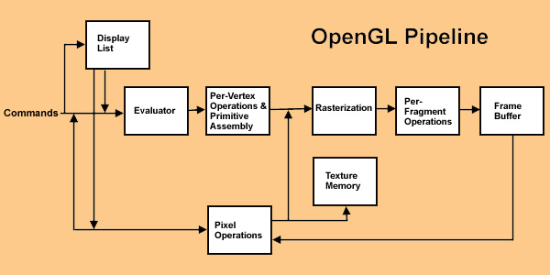

2.2 Display Lists
All data, whether it describes geometry or pixels, can be saved in a display list for current or later use. (The alternative to retaining data in a display list is processing the data immediately - also known as immediate mode.) When a display list is executed, the retained data is sent from the display list just as if it were sent by the application in immediate mode.
2.3 Primitive Assembly
Clipping, a major part of primitive assembly, is the elimination of portions of geometry which fall outside a half-space, defined by a plane. Point clipping simply passes or rejects vertices; line or polygon clipping can add additional vertices depending upon how the line or polygon is clipped.
In some cases, this is followed by perspective division, which makes distant geometric objects appear smaller than closer objects. Then viewport and depth(z coordinate) operations are applied. If culling is enabled and the primitive is a polygon, it then may be rejected by a culling test. Depending upon the polygon mode, a polygon may be drawn as points or lines. The results of this stage are complete geometric primitives, which are the transformed and clipped vertices with related color, depth, and sometimes texture-coordinate values and guidelines for the rasterization step.
2.4 Pixel Operations
While geometric data takes one path through the OpenGL rendering pipeline, pixel data takes a different route. Pixels from an array in system memory are first unpacked from one of a variety of formats into the proper number of components. Next the data is scaled, biased, and processed by a pixel map. The results are clamped and then either written into texture memory or sent to the rasterization step.
If pixel data is read from the frame buffer, pixel-transfer operations (scale, bias, mapping, and clamping) are performed. Then these results are packed into an appropriate format and returned to an array in system memory. There are special pixel copy operations to copy data in the frame buffer to other parts of the frame buffer or to the texture memory. A single pass is made through the pixel transfer operations before the data is written to the texture memory or back to the frame buffer.

2.5 Rasterization
Rasterization is the conversion of both geometric and pixel data into fragments. Each fragment square corresponds to a pixel in the frame buffer. Line and polygon stipples, line width, point size, shading model, and coverage calculations to support ant aliasing are taken into consideration as vertices are connected into lines or the interior pixels are calculated for a filled polygon. Color and depth values are assigned for each fragment square.

CHAPTER 3.
REQUIREMENT SPECIFICATIONS

3.1 SOFTWARE REQUIREMENTS SPECIFICATION:
This section attempts to bring out the requirements and specifications as given out by the Vishweshwaraiah Technological University for the completion of the package.

Minimum requirements expected are cursor movement, editing picture objects like point, line, circle, ellipse and polygons. Transformations on objects/selected area should be possible. User should be able to open the package do the required operations and exit from the environment.
Good user interface, which can be GUI, Menu based, should be provided.. Should use all most all the graphical input technologies for efficient programming and interact through various input devices. Should be a device independent package that is able to compile and create an executable.

Minimum software specification
- Operating system :Windows
- Visual C++
- OPENGL Library

3.2 EXTERNAL INTERFACE REQUIREMENTS

3.2.1 User Interface:
The interface for the 2D package requires for the user to have a mouse connected, and the corresponding drivers software and header files installed.
For the convenience of the user, there are menus and sub –menus displayed on the screen.

3.2.2 Hardware Interface
The standard output device, as mentioned earlier has been assumed to be a color monitor. It is quite essential for any graphics package to have this, as provision of color options to the user is a must. The mouse, the main input device, has to be functional. A keyboard is also required. Apart from these hardware requirements, there should be sufficient hard disk space and primary memory available for proper working of the package.

3.2.3 Software Interface
The editor has been implemented on the DOS platform and mainly requires an appropriate version of the compiler to be installed and functional. Though it has been implemented on DOS, it is pretty much platform independent with the restriction that there is support for the execution of C++ files. Text mode is recommended.

3.3 HARDWARE REQUIREMENTS
Minimum hardware specification
- Processor :INTEL/AMD processor
- Main memory: 1 GB RAM
- Hard Disk : 20 GB

CHAPTER 4.
SYSTEM DESIGN
4.2. Design of The Snake Game:
In the design of The Snake Game a number of squares are drawn in the screen forming an animated creature which is supposed to eat a Food Particle (also in the form of square).
The squares forming the body parts of the snake are to be drawn at the appropriate position in the screen so as they can be viewed as a single large entity. The snake can be seen in the red color while the Food Particle (food) can be seen in yellow color.
The go() function is mainly used to determine the position of each of the square within the window based on the user inputs. The displaysnake() function is responsible to draw the snake in appropriate location.
The newFood() function generates a random location in the screen to display the Food Particle. The function collision() determines the instance when the snake tries to cross its own path and informs the display() function by setting the gameOver bit.

4.2.1 Structure
The functions used in the project are:
- main function
- myreshape
- display
- go
- key_pressed_is
- CreateFood Particle
- DisplaySnake
- frontScreen
- collision
CHAPTER 5.

IMPLIMENTATION & BUILTIN FUNCTIONS

5.1 Functions
The glut library functions used are:

- void glBegin( GLenum mode ) and void glEnd( void )
  - mode: - Specifies the primitive or primitives that will be created from vertices presented between glBegin and the subsequent glEnd.
- void glPushMatrix();
  - glPushMatrix pushes the current matrix stack down by one, duplicating the current matrix. That is, after a glPushMatrix call, the matrix on top of the stack is identical to the one below it.
- void glPopMatrix();
  - glPopMatrix pops the current matrix stack, replacing the current matrix with the one below it on the stack.
- void glMatrixMode( GLenum mode )
  - Specifies which matrix stack is the target for subsequent matrix operations.
- void glClear( GLbitfield mask )
  - glClear sets the bitplane area of the window to values previously selected by glClearColor, glClearIndex, glClearDepth, glClearStencil, and glClearAccum.
- void glViewport( GLint x, GLint y, GLsizei width, GLsizei height );

  - Specify the width and height of the viewport. When a GL context is first attached to a window, width and height are set to the dimensions of that window.

- void glTranslate{fd} ( GLdouble x, GLdouble y, GLdouble z );

  - produces a translation by $("x","y","z")$. The current matrix (see
glMatrixMode) is multiplied by this translation matrix, with the product replacing the current matrix.

- void glutIdleFunc (void( *callback )( void ));

  - When glutMainLoop() is doing nothing else, it checks to see if an ''idle'' callback set. If so, that callback is invoked.

- glutTimerFunc(unsigned int msec, void( *callback )( int data ), int data);

  - After at least msec milliseconds, OpenGLUT will call callback , passing in your user-supplied data parameter. OpenGLUT will call your function only once.

- void gluOrtho2D( GLdouble left, GLdouble right, GLdouble bottom, GLdouble top );

  - left, right :Specify the coordinates for the left and right vertical clipping planes. bottom, top :Specify the coordinates for the bottom and top horizontal clipping planes.

- void glRasterPos2{fd} ( GLdouble x, GLdouble y );

  - specify the raster position for pixel operations

- glutMainLoop(void);

  - This is the main driving force for an event-driven OpenGLUT program. It alternates between calling glutMainLoopEvent() to process pending events and then either sleeping or calling your idle function.

CHAPTER-6
SOURCE CODE

#include <stdio.h>
#include <stdlib.h>
#include <windows.h>
#include <gl/glut.h>

#define up_dir 1
#define down_dir 2
#define left_dir 3
#define right_dir 4
#define GLUT_KEY_ESC 27

// Status Variables
int lvl = 1;
int Score = 0;
int body_count = 0;
byte gameOver = true;

// Variables of snake
int BodyPart[2][40];
int _x = 0;
int _y = 0;
int _oldX[2];
int _oldY[2];
byte direction = 0;
byte prevDirection= 0;

// Variables of Food Particle
int _bx = 0;
int _by = 0;

// Screen Variables
int _w = 500; //window width
int _h = 500; //window height
int BLw = 10;
int BLh = 30; // bottom-left corner
int TRw = 240;
int TRh = 240; // top-right corner

void resetSnkPos(){
_x = BLw+10; //////starting position
_y = BLh+30;
direction = 0;
lvl = 1;
Score = 0;
body_count = 0;
gameOver = false;
}

void Display_on_screen(char *string){
while(*string)
glutBitmapCharacter(GLUT_BITMAP_8_BY_13, *string++);
}

void front_screen(){
char tmp_str[40];
glColor3f(0, 0, 0);/// BLACK Background
glRectf(BLw, BLh, TRw, TRh);
glColor3f(.13, 0.25, 1);
//glRasterPos2f(0,0);
glRasterPos2f((BLw+TRw)/2-50,210);
Display_on_screen("Sachin P");
//glColor3f(0, 0, 0);
//glRectf(BLw, BLh, TRw, TRh);
//glColor3f(1, 1, 1);
glRasterPos2f((BLw+TRw)/2-50, 205);
Display_on_screen("Sri Ram Deepak");

glRasterPos2f((BLw+TRw)/2-50,195);
Display_on_screen("NEW GAME: Press enter to start");
glRasterPos2f((BLw+TRw)/2-50, 190);
Display_on_screen("INSTRUCTION: Make the snake longer by feeding the snake");

glRasterPos2f(110, 148);
Display_on_screen("OPENGL PROJECT");
glColor3f(.4, .4, .4);
glRectf(65, 130, 200, 145);
glColor3f(1, 1, 1);
glRasterPos2f(105, 135);
Display_on_screen("Snake Game");
// Print the Level and Points Status
glColor3f(0, 0, 0);
glRasterPos2f(10,20);
sprintf(tmp_str, "Last Game Score");
Display_on_screen(tmp_str);
glRasterPos2f(6, 6);
sprintf(tmp_str,"Lvl: %d Pts: %d", lvl, Score);
Display_on_screen(tmp_str);

}

void DisplaySnake(){
int i;

glPushMatrix(); // Display head
glTranslatef(_x,_y,0.0);
glColor3f(1, 0, 0);
glRectf(0, 0, 10, 10);
glColor3f(1, 1, 1);
glPointSize(3);
glBegin(GL_POINTS);
if(direction==right_dir)
{
glVertex2f(8,8);
glVertex2f(8,2);
}
if(direction==up_dir)
{
glVertex2f(2,8);
glVertex2f(8,8);
}
if(direction==left_dir)
{
glVertex2f(2,2);
glVertex2f(2,8);
}
if(direction==down_dir)
{
glVertex2f(2,2);
glVertex2f(8,2);
}
glEnd();
glPopMatrix();

for(i=0; i<body_count; i++){
glPushMatrix();
glTranslatef(BodyPart[0][i],BodyPart[1][i],0.0);
glColor3f(1, 0, 0); //Display Body
glRectf(0, 0, 10, 10);
glPopMatrix();
}
}

void CreateFood(){
char tmp_str[40];

// Create a Black background
glColor3f(0, 0, 0);
glRectf(BLw, BLh, TRw, TRh);

// Position the Food
glPushMatrix();
glTranslatef(_bx,_by,0.0);
glColor3f(1,1,0);//Colour of the Food //Display Food
glRectf(0, 0, 10, 10);
glPopMatrix();

// Print the Level and Points Status
glColor3f(0, 0, 0);
glRasterPos2f(10, 10);
sprintf(tmp_str, "Lvl: %d Pts: %d", lvl, Score);
Display_on_screen(tmp_str);
}

int RandomNumber(int high, int low)
{
return (rand() % (high-low))+low;
}

void newFoodPos(){
_bx = RandomNumber(TRw/10-BLw, BLw/10+1); /// high==14 && low==2;
_bx = _bx*10;
_by = RandomNumber(TRh/10-BLh, BLh/10+1); /// high==21 && low==4
_by = _by*10;
}

bool collission(){
int i;

for(i=0; i<body_count; i++)
{
if(BodyPart[0][i] == _x && BodyPart[1][i] == _y) return true;
}
return false;
}

void go(int value)
{
int i;
_oldX[1] = _x;
_oldY[1] = _y;
switch(direction){
case right_dir:
_x += 10;
if(_x > TRw-10) _x = BLw;
break;
case left_dir:
_x -= 10;
if(_x < BLw) _x = TRw-10;
break;
case up_dir:
_y += 10;
if(_y > TRh-10) _y = BLh;
break;
case down_dir:
_y -= 10;
if(_y < BLh) _y = TRh-10;
break;
}

if(collission()) {Sleep(700);gameOver = true;}

//gameOver=collission();

if(_x == _bx && _y == _by){
Score++;
if(Score < 40) body_count++;
if(Score%5 == 0 && lvl < 15) lvl++;
newFoodPos();
}

for(i = 0; i<body_count; i++){
_oldX[0] = _oldX[1];
_oldY[0] = _oldY[1];
_oldX[1] = BodyPart[0][i];
_oldY[1] = BodyPart[1][i];
BodyPart[0][i] = _oldX[0];
BodyPart[1][i] = _oldY[0];
}

glutTimerFunc(140-lvl*8, go, 0);
}

void display(void){
glClearColor(1, 1, 1, 1);
glClear(GL_COLOR_BUFFER_BIT);

if(!gameOver){
CreateFood();
DisplaySnake();
}
else
front_screen();

glutPostRedisplay();
glutSwapBuffers();
}

void key_pressed_is(int key, int x, int y){
switch(key){
case GLUT_KEY_RIGHT :
if(direction != left_dir )
{
prevDirection=direction;
direction = right_dir;
}

glutPostRedisplay();
break;

case GLUT_KEY_LEFT :
if(direction != right_dir)
{
prevDirection=direction;
direction = left_dir;
}
glutPostRedisplay();
break;

case GLUT_KEY_UP :
if(direction != down_dir)
{
prevDirection=direction;
direction = up_dir;
}
glutPostRedisplay();
break;

case GLUT_KEY_DOWN :
if(direction != up_dir)
{
prevDirection=direction;
direction = down_dir;
}
glutPostRedisplay();
break;
}
}

void mykey(unsigned char key,int x,int y)
{

if(key=='q' || key=='Q')
exit(0);
if(key==27)exit(0);
if(key==13 && gameOver)
resetSnkPos();

}

void myreshape(GLsizei w, GLsizei h){
glViewport(0, 0, w, h);
glMatrixMode(GL_PROJECTION);
glLoadIdentity();
if (w <= h)
gluOrtho2D (0, 250, 0, 250*_h/_w);
else
gluOrtho2D (0, 250*_w/_h, 0, 250);
}
void myinit()
{
glMatrixMode(GL_PROJECTION);
glLoadIdentity();
gluOrtho2D(0,500,0,500);
glMatrixMode(GL_MODELVIEW);
}

int main(void)
{
glutInitDisplayMode(GLUT_DOUBLE | GLUT_RGB);
glutInitWindowSize(_w,_h);
glutInitWindowPosition(0,0);
glutCreateWindow("Snake Game");
myinit();
glutSpecialFunc(key_pressed_is);
glutDisplayFunc(display);
glutReshapeFunc(myreshape);
glutKeyboardFunc(mykey);
newFoodPos();
go(0);

glutMainLoop();
return 0;
}

CHAPTER-7 SNAPSHOT

7.1 SNAPSHOTS

7.1.1 Main page :

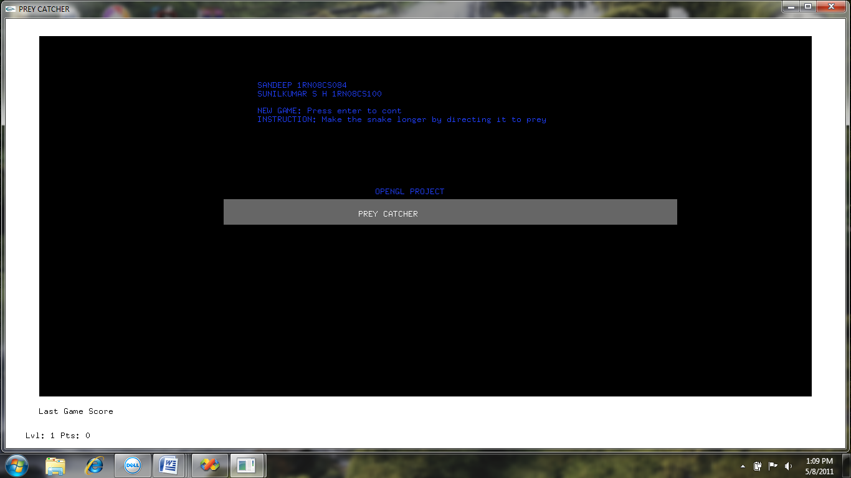

7.1.2 Initial position :

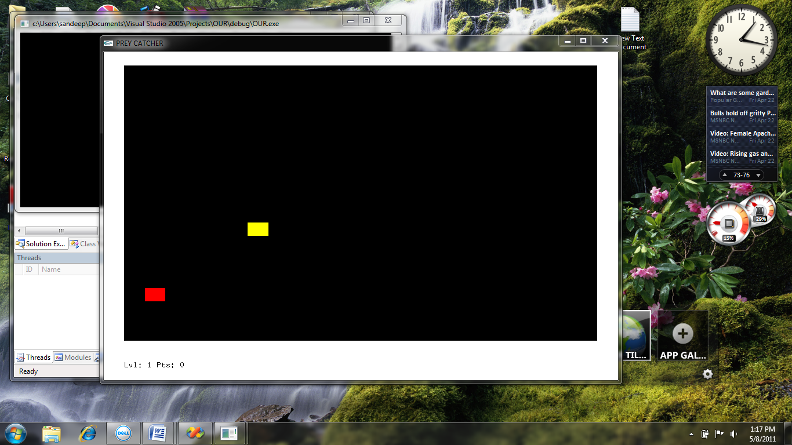

7.1.3 At level 5 :

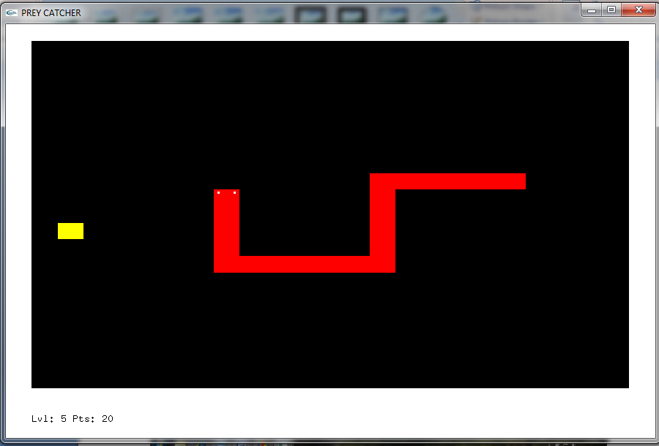

CHAPTER 8.

CONCLUSION

The aim of the project was to understand the concepts of computer graphics through experiencing the powerful functionalities of openGL API’s .The code have been written in C++ with openGL API’s .The code contains comprehensive details of implementations in openGL and functionalities they enhance.The above gaming application which is developed in 2D can also be extended to 3D and multiplayer options included by adding other features.

REFERENCES

[1] Edward Angel., “Interactive Computer Graphics A Top-Down Approach with OpenGL”, 5th Edition, Addison-Wesley, 2008.

[2] F.S. Hill,Jr., “Computer Graphics Using OpenGL”, 2nd Edition,
Pearson Education, 2001.

[3] James D Foley, Andries Van Dam, Steven K
Feiner, John F Hughes,”Computer Graphics”,Addison-wesley 1997.

[4] Donald Hearn and Pauline Baker.,”Computer Graphics - OpenGL Version”, 2nd Edition, Pearson Education, 2003.

Websites:
- http://www.opengl.org
- http://nccastaff.bournemouth.ac.uk/jmacey/

